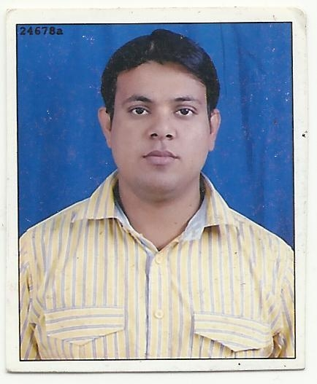
CURRICULUM VITAE

Farhat Husain
Address: - Village & Post Nizampur Malhaur, Lucknow
Pin 226028.
Contact Numbers: - +91-9450971332, 8423557782
Email: - Farhathusain86@gmail.com

Career Objective:
Seeking a challenging and responsible position in your organization to use my skills. and knowledge and have a flexibility to adapt to any new environment in industry that offer professional growth while being resourceful, innovative and flexible.

Qualifications:

Professional Qualification:

- One year of computer diploma (BDCA) from government Institute (GCEC Lucknow).

- HCL Certified A+ from HCLCDC Center Lucknow.

- Done CCC Computer Diploma from DOEACC Center Lucknow.

EXPERINCE:-

- 27 Month Senior Customer Care Executive Work On K&E Desk in airtel

Dth Lucknow (Aegis BPO Ltd).

- 2 Year Experience in DEWESOFT OVERSEAS LTD.

- 1 Year Experience in Data Collection in RELIANCE LIFE.
- 6 Month Experience in Paytm One97 Communication As Sales Fse.

Educational Qualification:

- B.Com : S.P.G College University of Lucknow (2008)

- Intermediate : S.Vardhman Inter College, Lucknow. (2005)

- High school : S.B.S Inter College, Lucknow (2003)

SKILLS

- Easily adapt myself in work environment.
- Hard working.
- Positive attitude.

IT/Technical Skills
- Office Package: - Microsoft Office XP 2003, 2007, A+

- Good knowledge about the Internet and E-mailing.
- Computer organization and architecture.

Personal Profile:

Fathers Name : - Mr. Ishrat Husain
Date of Birth : - 25-09-1985
Marital Status : - Married
Hobbies : - Listing music, traveling
Nationality : - Indian
Language Known : - Hindi, English, Urdu

I Farhat Husain hereby declare all that the information furnished above is true to the best of my knowledge.

Date: NAME:

PLACE: (Farhat Husain)

Place: Signature

